**1.**

**PROBLEM**

**CSS - font size**

With more than a decade of experience in making web designing, Bamboo Web Designers has evolved itself to be known as one of the top web designing companies in the city. Pink Frag Event Organizer has signed up a deal with Bamboo Web Designers for maintaining the website of their organization.  
  
The Event company wanted to create a blog which would be useful and innovative for the customers. As the web designing team is busy with other projects, the Team Lead of Bamboo Web Designers have assigned you the task of creating the webpage in which the size of the letters should convey the importance of the content.  
  
Create a webpage for Pink Frag Event Organizer with the neccesary details about the company using font size attribute in CSS.

**Hints :**  **font size**

It is used in altering the font size of any element in the webpage.

Syntax :

 <style>

 h2 {

        font-size:20px;

}

 </style>

**Content :**  
Content are given as a part of template.  
  
**Constraints :**  
Use the following font size for the tags using Style property;  
h2 - 18px  
h3 - 16px  
h5 - 14px  
p  - 10px  
  
**Note :**  
Use Internal style property for styling the webpage.  
Content of the page should be present as shown in the screenshot.  
Kindly refer the content which is given as a part of description.  
  
**Sample Screenshot 1 :**  
  
Before applying styles  
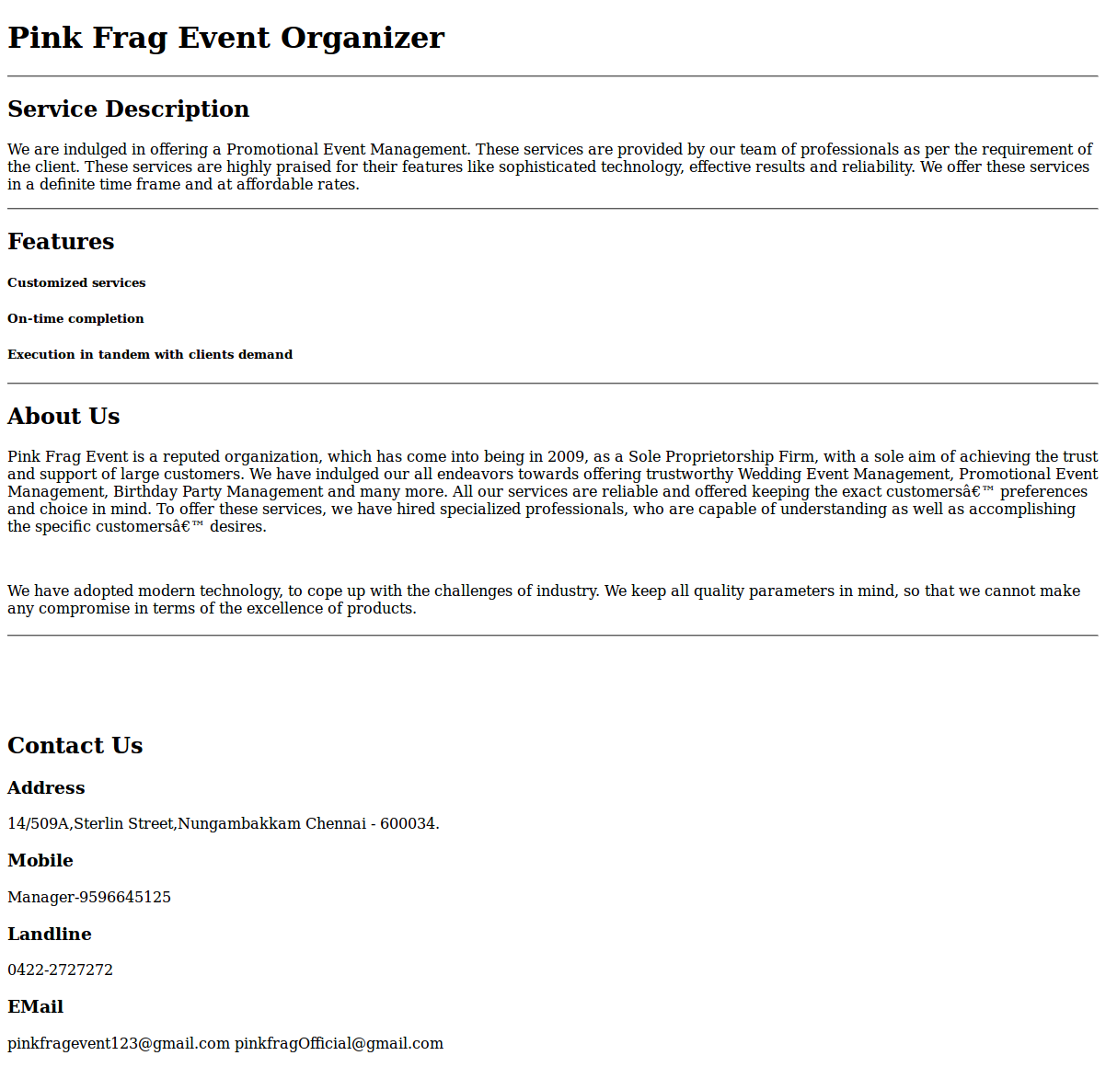  
  
**Sample Screenshot 2 :**  
  
After applying styles  
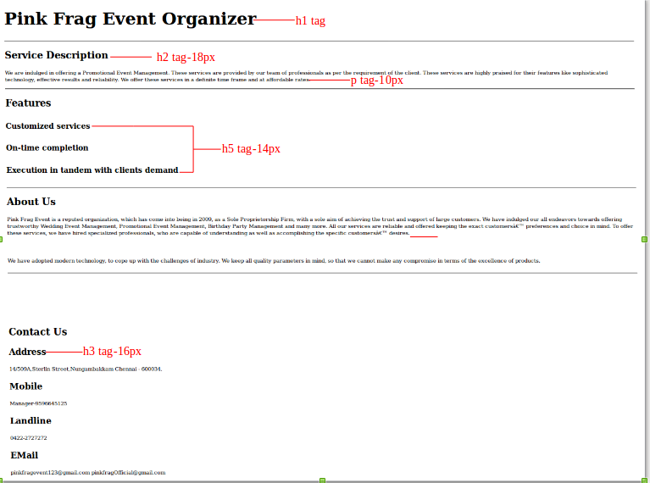

*2. HTML Basics - wbr tag*

Shinja is working in a project related to the rarely used properties in HTML .On listing the rarely used properties, <wbr> tag holds a specific place among the other properties.On doing a thorough study, she found that the <wbr> tag defines a potential line break point if needed. This stands for Word Break Opportunity. As it sounds similar to the <br> tag, it holds a peculiarity where the <br> tag forces a line break while <wbr> tag only represents a line break opportunity. It only facilitate the browser to line break if necessary .



Now, she is in need of your help to create a html webpage which explains the tags like <wbr> with rare usage. Hence, create a webpage using <wbr> tag helping her to finish her project work as soon as possible. 

 Hints :  Tag <wbr>  The <wbr> (Word Break Opportunity) tag specifies where in a text it would be ok to add a line-break. When a word is too long, or you are afraid that the browser will break your lines at the wrong place, you can use the <wbr> element to add word break opportunities. Syntax :  The <wbr> tag is written as <wbr> (no end tag). It is placed wherever a line breaking opportunity exists.

Content :  
h1 - HTML - wbr tag  
p - The world record for the longest word is <i>Lopadotemachoselachogaleokranioleipsanodrimhypotrimmatosilphioparaomelitokatakechymenokichlepikos syphophattoperisteralektryonoptekephalliokigklopeleiolagoiosiraiobaphetraganopterygon</i>  
[Note: Consider the above <i> content as single word without any break]  
p -It is a fictional dish mentioned in Aristophanes' comedy Assemblywomen. It is a transliteration of the Ancient Greek word translated as "name of a dish compounded of all kinds of dainties, fish, flesh, fowl, and sauces"  
  
Use  <wbr> in between the <i> word to have a line break.  
  
Constraints:  
Tag 'wbr' must be present minimum 3 times in the html page.  
Use the header and the content as given in the problem content.  
  
Note :  
Content of the page should be present as shown in the screenshot.  
Kindly refer the content which is given as a part of description.  
  
Sample Screenshot 1 :  
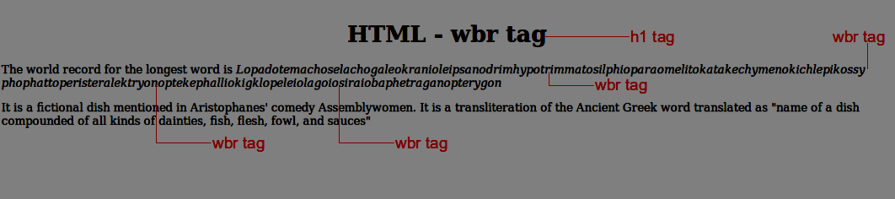  
  
  
Sample Screenshot 2 :  
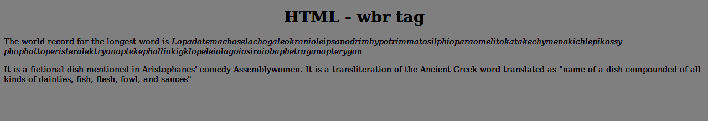

3.HTML Basics - center tag

Alaska Card Makers are the best in making unique and innovative invitations for special occasions like weddings, house warming, birthdays etc,. Marlin has newly joined the company and he has been assigned the task of creating a party invitation card for the company's new client Mr.Peter on account of his Holiday Party. Its the right time for Marlin to show his artistic talent in making a card that conveys emotions and hopes. He surfed many websites for the prototypes and came out with a design that is more aesthetic. The design should display the card's main contents embolded at the center. Let us help Marlin by creating an invitation model web page using center tag.

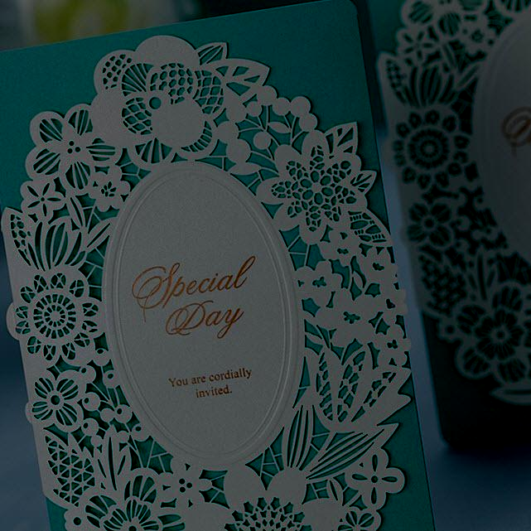

Hints :

Tag <center>

The <center> tag is used to center-align text.

Syntax :

<center> </center>

Content :  
center -  
h3 - Invitation for de'Party  
Peters, Wells & Bingham invites you and your family to their annual Holiday Party for cocktails and hors d'oeuvres. Would be a Great eve !!! Lots of fun and entertainment for the gatherings..Funny activities been planned for kids...Awaiting for the moment of happiness   
<hr>  
Saturday, December 8th  8 o’clock in the evening Sun Valley Resort & Spa 12 Sun Road Sun Valley, California  
  
Constraints :  
The contents of the html page should be present inside the 'center' tag.

Note :  
Content of the page should be present as shown in the screenshot.  
Kindly refer the content which is given as a part of description.  
  
Sample Screenshot 1 :  
  
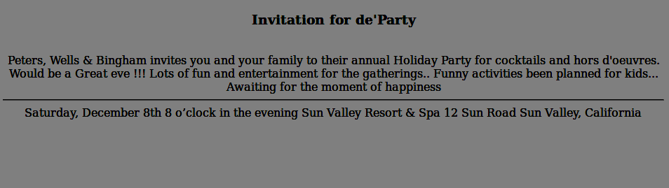  
  
Sample Screenshot 2 :  
  
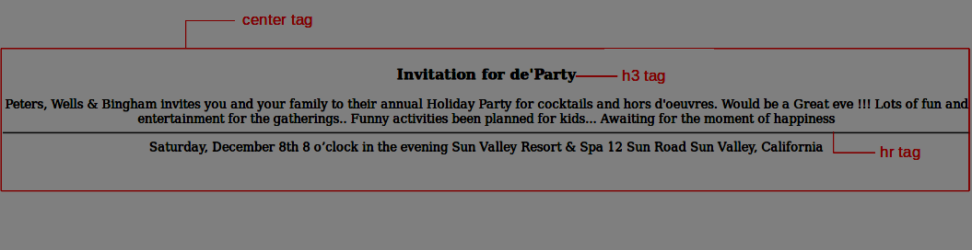

4. HTML Basics - br & hr tags

The Pink Frag Event Organization is offering trustworthy Wedding Event Management, Promotional Event Management, Birthday Party Management and many more. To expand their business, they thought of creating a website for the company to  improve customer interaction. Presentation of the website was taken to the highest priority. The contents in web pages usually should be separated from other contents and there must be appropriate breaks in the page. To ensure this capability, there are two tags namely <hr> and <br> tags. The organization needed to implement these tags in his web page.  
  
Let us help them to use the <hr> and <br> tags in his web page.

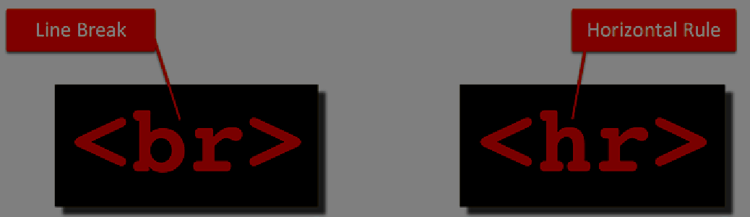

Hints :

Tag <hr>

The <hr> tag defines a thematic break in an HTML page.

In HTML, the <hr> tag has no end tag.

The <hr> element is used to separate content (or define a change) in an HTML page.

Tag <br>

The <br> tag inserts a single line break.

The <br> tag is an empty tag which means that it has no end tag.

Content :  
H1 - Pink Frag Event Organizer  
HR  
H2 - Service Description  
P - We are indulged in offering a Promotional Event Management. These services are provided by our team of professionals as per the requirement of the client. These services are highly praised for their features like sophisticated technology, effective results and reliability. We offer these services in a definite time frame and at affordable rates.  
HR  
H2 - Features  
H5 - Customized services  
H5 - On-time completion  
H5 - Execution in tandem with clients demand  
HR  
H2 - About Us  
p- Pink Frag Event  is a reputed organization, which has come into being in 2009, as a Sole Proprietorship Firm, with a sole aim of achieving the trust and support of large customers. We have indulged our all endeavors towards offering trustworthy Wedding Event Management, Promotional Event Management, Birthday Party Management and many more. All our services are reliable and offered keeping the exact customers’ preferences and choice in mind. To offer these services, we have hired specialized professionals, who are capable of understanding as well as accomplishing the specific customers’ desires.  
 <br>  
We have adopted modern technology, to cope up with the challenges of industry. We keep all quality parameters in mind, so that we cannot make any compromise in terms of the excellence of products.  
HR  
<br>  
<br>  
<br>  
<br>  
 H2 - Contact Us  
 H3 - Address  
 p - 14/509A,Sterlin Street,Nungambakkam Chennai - 600034.  
 H3 - Mobile  
 p - Manager-9596645125  
 H3 - Landline  
 p - 0422-2727272  
 H3 - EMail  
 p - pinkfragevent123@gmail.com pinkfragOfficial@gmail.com  
  
Constraints :  
Tag 'hr' must be present minimum 3 times in the html page.  
Tag 'br' must be present minimum 5 times in the html page.  
  
Note :  
Content of the page should be present as shown in the screenshot.  
Kindly refer the content which is given as a part of description  
  
Sample Screenshot 1 :  
  
